1) Download jolokia-jvm-1.2.3-agent.jar from http://search.maven.org/#artifactdetails%7Corg.jolokia%7Cjolokia-jvm%7C1.2.3%7Cjar and put it in D:\JarsAndWars

2) Making jolokia SSL enabled: (if you don’t want jolokia to be SSL enabled, skip this step) for this POC purpose, I’ve used self-signed certificate.

2.1) Create the jks (java keystore) file: (this file is container for our self-signed certificate)

Open cmd in admin mode. Go to run, type cmd and hit Ctrl+Shift+enter. Navigate to jdk/bin and enter following command:

keytool -genkey -keyalg RSA -alias localhost -keystore D:/JarsAndWars/keystore.jks -storepass password -validity 360 -keysize 2048

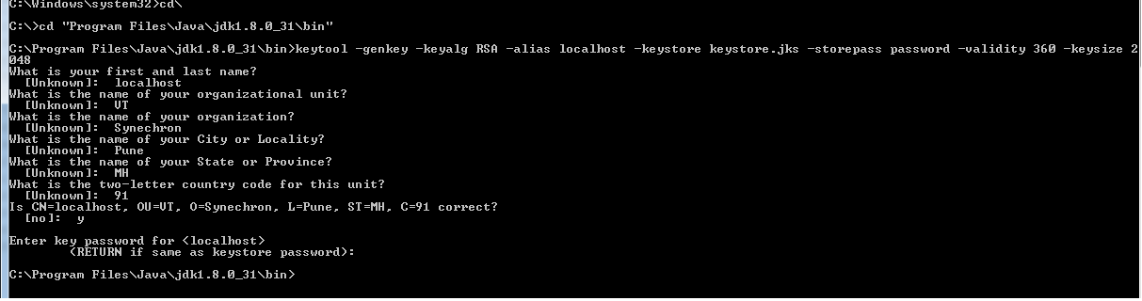

This will generate keystore.jks at location D:/JarsAndWars. This jks file will contain the self-signed cert with alias 'localhost'. To view it, you can use below command at D:/JarsAndWars:

keytool -list -storepass password -keystore keystore.jks

2.2) Export the certificate from keystore.jks file:

keytool -exportcert -storepass password -keystore D:/JarsAndWars/keystore.jks -alias localhost > D:/JarsAndWars/localself.crt

This command will export the self-signed cert with alias 'localhost' from the jks file, name it localself.crt and put it in D:/JarsAndWars.

2.3) Import the certificate (which we created in step 2) to jre/lib/security/cacerts:

Open cmd in admin mode. Navigate to C:\Program Files\Java\jre1.8.0_31\bin and use below command:

keytool -import -alias localhost -file D:/JarsAndWars/localself.crt -keystore ../lib/security/cacerts

Enter keystore password: changeit

Use below command to make sure it has newly created cert entry:

keytool -list -storepass changeit -keystore ../lib/security/cacerts

3) Run your application (to which you want to attach jolokia JVM agent) with following VM arguments:

For HTTP:

-javaagent:D:\JarsAndWars\jolokia-jvm-1.2.3-agent.jar=port=7777,host=localhost

For HTTPS:

-javaagent:D:\JarsAndWars\jolokia-jvm-1.2.3-agent.jar=port=7777,host=localhost,protocol=https,keystore=D:/JarsAndWars/keystore.jks,keystorePassword=password

This will start the jolokia jvm agent which will listen for requests on http(s)://127.0.0.1:7777/jolokia/ (it will provide JMX over HTTP-JSON)

You can also attach a jolokia jvm agent to an already running application.

4) Download hawtio-app-1.4.45.jar from http://hawt.io/getstarted/ Hawtio provides a webconsole to access jolokia agents. In cmd, navigate to the folder where you downloaded the jar and run following command:

java -jar hawtio-app-1.4.45.jar --port 8090

This will start hawtio on url : http://localhost:8090/hawtio It automatically opens this url in a browser.

Establish a remote connection to the jolokia agent by providing host name, port and path to application:

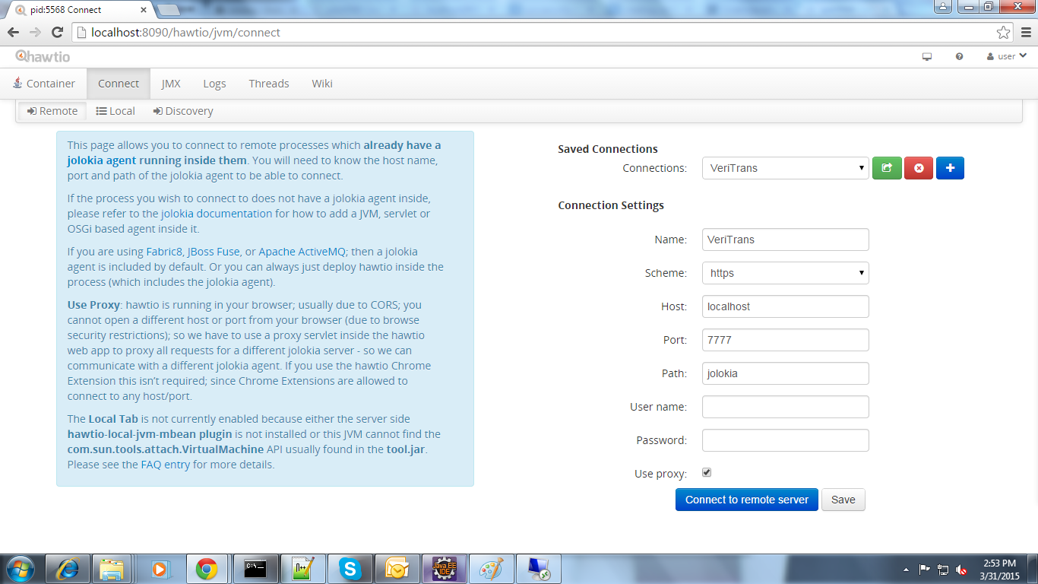

Pressing on Connect will establish a remote connection to jolokia jvm agent running on localhost:7777 Go to JMX tab to see the exposed JMX beans.

